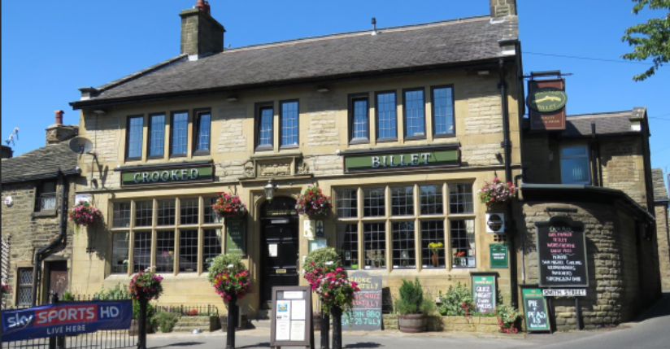

CROOKED BILLET TRAIL RACE
RACE IS ON PATHS AND TRACKS IN WORSTHORNE – DISTANCE APPROX 6 MILES

WEDNESDAY JUNE 22ND AT 7PM
REGISTRATION opens at 6pm AND PRIZE GIVING AT THE CROOKED BILLET after the race has finished
START AND FINISH FROM GORPLE ROAD WORSTHORNE (Please park responsibly within the village and respect the locals)
Please arrive in plenty of time to park, register and get to the start line!
Prizes for all age categories (Sportsshoes.com vouchers)
Entry fees are £5 and £7 unattached
Please fill out the form below and bring to registration:
FIRST NAME:__________________________SURNAME:__________________
ADDRESS:__________________________________________________________
POST CODE______________________TEL:_____________________________ MALE/FEMALE____
AGE ON DAY OF RACE
(Min. 16 years): _______ Date of Birth: ___________________ CLUB_________________________________

UKA/EA Reg No.___________________ Entry fee …£5
UNATTACHED ………. Entry fee £7

I hereby agree that any participation by me in the Event is solely and entirely at my own risk and (to the extent permitted by law) no person(s) or organisation(s) shall be liable for any accident, harm, injury, loss or damage to property, however so caused, arising out of or in connection with or, suffered during or as a result of, my participation in the Event. I also agree that the organisers may alter details of the race without notice and that, in the unlikely event of abandonment, all or part of my entry fee may not be refunded. SIGNATURE (Parent/Guardian if aged under 18) __________________________
DATE _____________________

